Annual Marian Consecration

with Bishop Edward B. Scharfenberger

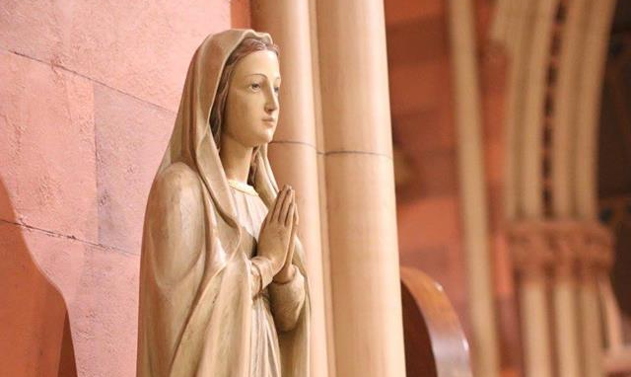

Thursday, December 8 at 12:15 PM
Cathedral of the Immaculate Conception
125 Eagle St., Albany, NY

Bishop Scharfenberger is inviting everyone in the diocese to join him in a 33-day preparation period with the book, 33 Days to Morning Glory, or a book of one’s choice, beginning Saturday, November 5, 2022 to Consecrate/Renew our Consecration to Jesus through Mary. The preparation will culminate with the consecration at Bishop Ed’s diocesan consecration mass, on the Solemnity of the Immaculate Conception, a holy day of obligation, on Thursday, December 8, at the Cathedral of the Immaculate Conception. Please join the livestream from home or tune into a recording of the event at the Diocesan YouTube account at your convenience. More information: www.rcda.org/marianconsecration

Livestream: www.rcda.org/livestream

